**Multidisciplinary Conference on**

**Building India – Good to Great**

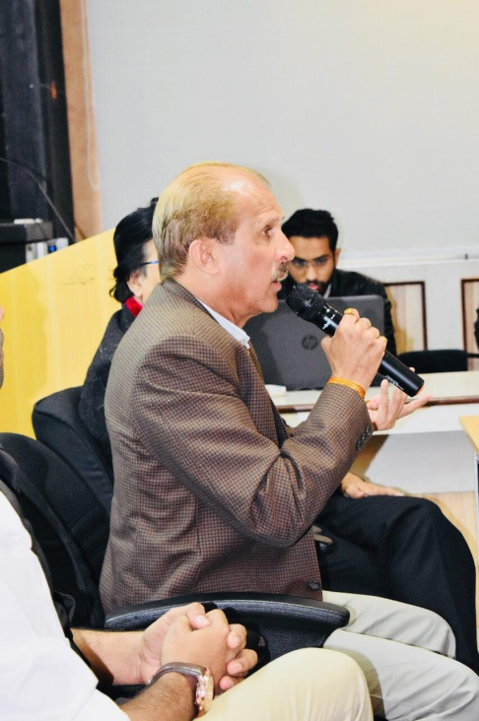Dr. Ashish Pathak speaking at the inagural emphasised that through such conferences intellectual ideas can be churned on many dimensions that can be explored in making India – India of dreams. Researchers from various streams ateended and presented their contributions. These contributions were published in UGC approved journal – Shodh Sarita.

